1. **Update the port of a Jenkins service**

Cd /etc/default

Vi jenkins

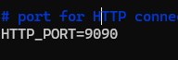

root@ip-172-31-22-132:/etc/default# cd /usr/lib/systemd/system

root@ip-172-31-22-132:/usr/lib/systemd/system# vi jenkins.service



Daemon reload and service restart

1. **Put Jenkins in Tomcat in a container**

Run tomcat: docker run -it -d -p 8081:8080 tomcat:9.0.93-jre21-temurin-jammy

Download the war file of Jenkins

root@ip-172-31-36-168:/home/ubuntu# wget <https://updates.jenkins.io/download/war/2.472/jenkins.war>

copy the downloaded file in container

cp jenkins.war 6d7e06c3a7468491de84e8c14afaff8539cf0db88012ff805be387b72c0f87de:/usr/local/tomcat/webapps

Open the session interactively

Docker exec –t <container id> /bin/bash

Check the url: ip address:8081/Jenkins

**Initial** password for Jenkins: /root/.jenkins/secrets/initialAdminPassword

1. Get a number from user and print next 100 numbers:

root@ip-172-31-47-32:/home/ubuntu/shellscript# cat 100num.sh

#!/bin/bash

read -p "Enter the number: " num

echo $num

max=$(($num + 100))

echo $max

echo "Next 100 numbers are:"

for (( i="$num"+1; i<="$max"; i++ ))

do

echo "$i"

done

1. Get a number from user and print its table.

#!/bin/bash

read -p "Enter the number: " num

echo $num

echo "Table is as follows:"

for (( i=1; i<=10; i++ ))

do

val=$(( num * i ))

echo "$num * $i = " $val

done

1. Print linecount, wordcount and charactercount in a file.

#!/bin/bash

filepath=$1

echo "File under test is: " $filepath

lineCount=`wc -l < $filepath`

echo "Line Count is: " $lineCount

wordCount=`wc --word < $filepath`

echo "Word Count is: " $wordCount

charCount=`wc -m < $filepath`

echo "Char Count is: " $charCount

1. Archive and Housekeeping Job:

root@ip-172-31-47-32:/home/ubuntu/shellscript# cat archive.sh

#!/bin/bash

srcPath=/home/ubuntu/shellscript/srcfolder

tgtPath=/home/ubuntu/shellscript/targetfolder

echo "Starting Archiving job as per scheduled time: "

cd $srcPath

cp * $tgtPath

echo "Archival process completed"

Schedule: 0 5 * * *

root@ip-172-31-47-32:/home/ubuntu/shellscript# cat housekeeping.sh

#!/bin/bash

tgtPath=/home/ubuntu/shellscript/targetfolder

echo "Starting Housekeeping job as per scheduled time: "

cd $tgtPath

rm -rf *

echo "Housekeeping process completed"

Schedule: 30 * * * *

1. why full storage is not available when you mount a storage

Linux reserves around 5% of storage for root user and system services. If disk space is full and no space left on drive, then no one will be able to login. Hence for smooth functioning of drive, space is reserved.

1. Automated SSH Setup – **NOT DONE**

#!/bin/bash

ipfile=$1

uuserfile=$2

#keyval=""

create_key(){

ssh-keygen -t rsa -N "" -f my.key

}

create_key

while read -r line; do

name="$line"

echo "IP Address from file - $name"

done < "$ipfile"

1. Create Hard Link and Soft Link

Hard link: root@ip-172-31-35-181:/home/ubuntu/script# ln sshconnect.sh testlink

Soft Link: root@ip-172-31-35-181:/home/ubuntu/script# ln -s sshconnect.sh test2

1. What is SWAP memory

Area where inused or inactive data of RAM is placed. System still functions if RAM is full and does not crash

1. What is IPTABLE?

In linux, firewall is implemented by Netfilter(a kernel module which regulates the internet traffic) IPTables are interface to Netfilter.

1. Virtualization vs (Docker) containerization

Creates VMs. Virtual version of Independent machines or computer resources created on basis of predefined configuration. Ex: separate images of Ubuntu, RHEL, AWS Linux etc. Performed using hypervisor.

Container is a lightweight process. Application is encapsulated within a container providing a minimalistic operating system. So application uses OS of container rather than reaching out to VM/machine where container is hosted

1. Docker info vs docker version vs docker --version

Docker --version: Just version of docker CLI

root@ip-172-31-35-181:/home/ubuntu# docker --version

Docker version 24.0.7, build 24.0.7-0ubuntu4

Docker version: prints version of docker components (client and server)

Docker info: Detailed information about docker environment and installation. Versions, plugins, number of images available in system, number of containers and grouped by history etc, Operating system, memory details, storage details etc

1. Remove a package from linux machine

Apt remove docker –y

1. Setting up webhook

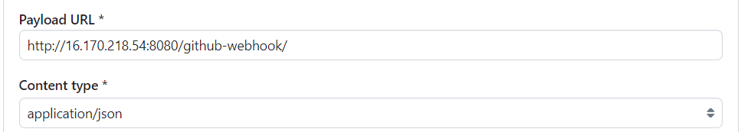

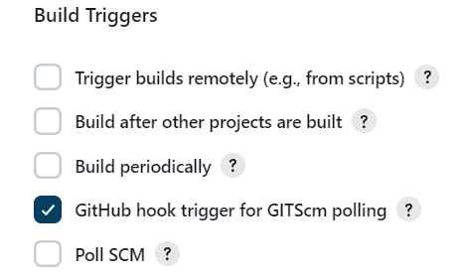

Pending questions:

add SSL in Jenkins URL

Automated Passwordless ssh

How to mount a storage

COnfigure old version of docker and then upgrade to newer version